**Exercise 4.2**

**1.Classify the following curves as (i) open or (ii) closed.**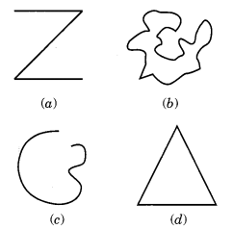  
Solution:  
(a) Open curve  
(b) Closed curve  
(c) Open curve  
(d) Closed curve

**2. Draw rough diagrams to illustrate the following:**(a) Open curve  
(b) Closed curve  
Solution:  
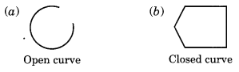

**3.Draw any polygon and shade**Solution:  
ABCD is the required polygon whose interior region is shaded.  
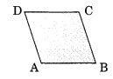

**4. Consider the given figure and answer the questions.**(a) Is it a curve?  
(b) Is it closed?  
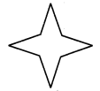  
Solution:  
(a) Yes, it is a curve.  
(b) Yes, it is closed curve.

**5. Illustrate, if possible, each one of the following with a rough diagram:**

(a) A closed curve that is not a polygon.

(b) An open curve made up entirely of line segments.

(c) A polygon with two sides.

Answer:

(a)

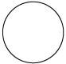

(b)

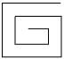

c)This is not possible as the polygon having the least number of sides is a triangle, which has three sides in it.

**Exercise 4.3**

**1.Name the angles in the given figure.**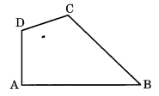  
Solution:  
The angles are:  
 (i) ∠A or ∠DAB  
 (ii) ∠B or ∠CBA  
 (iii) ∠C or ∠DCB  
 (iv) ∠D or ∠ADC.

**2. In the given diagram, name the point(s):**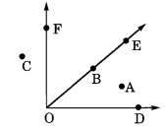  
(a) In the interior of ∠DOE

A is the point in the interior ∠DOE.  
  
(b) In the exterior of ∠EOF

C is the point in the exterior ∠EOF.

(c) On ∠EOF

B is the point on ∠EOF.

**3. Draw rough diagrams of two angles such that they have**(а) one point in common.

In figure (a), O is the common point of ∠AOB and ∠COB.  
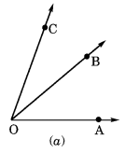

(b) two points in common.

In figure (b), O and P are the common points in ∠SOA and ∠OPQ.  
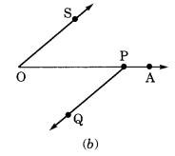  
(c) three points in common.

Such a diagram is not possible.  
(d) four points in common

Such a diagram is not possible.  
.  
(e) One ray in common.  
     
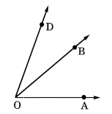  
 OB is the common ray of ∠AOB and ∠DOB.

**Exercise 4.4**

**1.Draw a rough sketch of a triangle ABC. Mark a point P in its interior and a point Q in its exterior. Is the point A in its exterior or in its interior?**Solution:  
 Triangle ABC is the given triangle.  
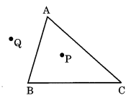  
 P is in the interior of ∆ABC.  
 Q is in the exterior of ∆ABC.  
 A is neither in the exterior nor in the interior.

**2. (a) Identify three triangles in the figure.**   
 (b) Write the names of seven angles.  
 (c) Write the names of six line segments.  
 (d) Which two triangles have ∠B as common?

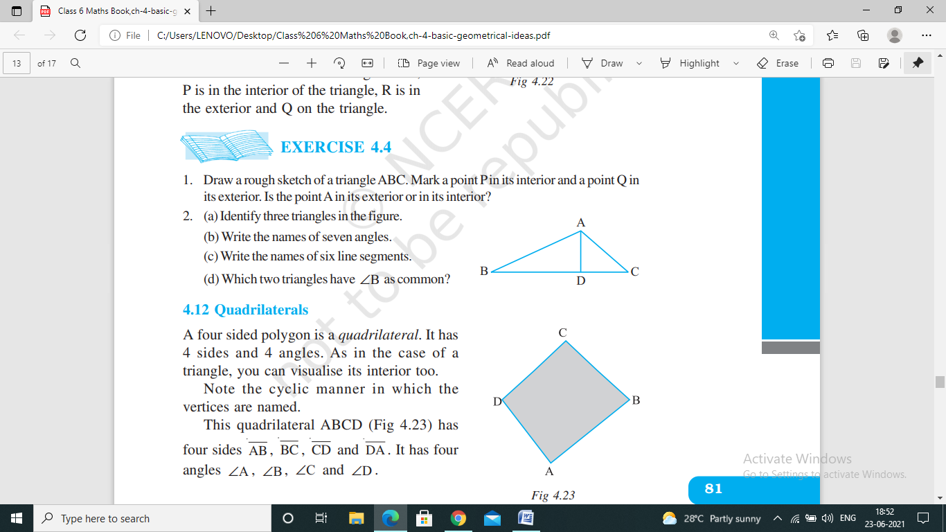

Solution:  
(a) Three triangles are: ∆ABC, ∆ABD and ∆ADC.  
(b) (i) ∠ABC  
(ii) ∠ADB  
(iii) ∠BAD  
(iv) ∠ADC  
(v) ∠ACD  
(vi) ∠DAC  
(vii) ∠BAC.  
(c) AB , BD , AD , AC , DC , BC  
(c) ∆ABC and ∆ABD have ∠B as common.

**Exercise 4.5**

**1.Draw a rough sketch of a quadrilateral PQRS. Draw its diagonals. Name them. Is the meeting point of the diagonals in the interior or exterior of the quadrilateral?  
Solution:**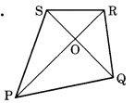  
 (i) We have a quadrilateral PQRS.  
 (ii) PR and QS are its two diagonals.  
 (iii) O is the meeting point of the diagonals PR and QS which is in the interior of the quadrilateral.

**2. Draw a rough sketch of a quadrilateral KLMN. State:**

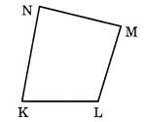  
 (a) two pairs of opposite sides

KLMN is the given quadrilateral.  
 KL , NM and KN , LM are the pairs of opposite sides.  
 (b) two pairs of opposite angles

∠K and ∠M, ∠L and ∠N are the pairs of opposite angles.  
 (c) two pairs of adjacent sides

 KL and KN, NM and ML are the pairs of adjacent sides.  
 (d) two pairs of adjacent angles.

∠K and ∠L, ∠N and ∠M are the pairs of adjacent angles.

**Exercise 4.6**

**1.From the figure, identify:**

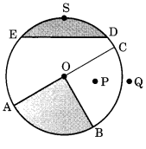  
 (a) the centre of circle

O is the centre of the circle.  
 (b) three radii

Three radii of the given circle are OA , OB and OC.  
 (c) a diameter

AC is a diameter of the circle.  
 (d) a chord

ED  is a chord of the circle.

(e) two points in the interior

O and P are in the interior of the circle.   
  
 (f) a point in the exterior

Q is a point in the exterior of the circle.  
 (g) a sector

OBA is a sector of the circle.   
 (h) a segment.

EDSE, the shaded region is a segment of the circle.

**2. (a) Is every diameter of a circle also a chord?**

Ans : (a) Yes, every diameter is the longest chord of a circle.  
  
(b) Is every chord of a circle also a diameter?  
 Ans : No, every chord is not diameter of a circle.

**3. Draw any circle and mark**  
 (a) its centre  
 (b) a radius  
 (c) a diameter  
 (d) a sector  
 (e) a segment  
 (f) a point in its interior  
 (g) a point in its exterior  
 (h) an arc.

Solution:  
 In the given circle,  
 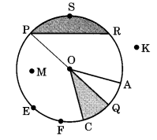  
 (a) O is the center.  
 (b) OA is a radius.  
 (c) PQ is a diameter.  
 (d) OQC is a sector (shaded part)  
 (e) PSR (shaded part) in the segment.  
 (f) M is in the interior of the circle.  
 (g) K is in the exterior of the circle.  
 (h) EF˘ is an arc of the circle.

**4. Say ‘true’ or ‘false’.**(a) Two diameters of a circle will necessarily intersect.

Ans : True  
(b) The centre of a circle is always in its interior.  
 Ans : True